Python function that takes three inputs and returns the largest value (Task #2)

PROMPT :

write a python code using a function to find maximum element in the given list for 3 ele elements and read input from the user..

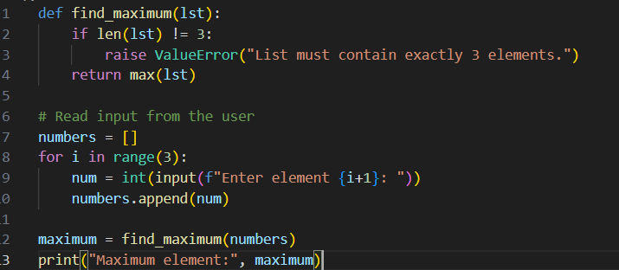Code :

Output :

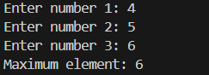

Python function for factorial using recursion (Task #3)

PROMPT :

Write a python code using a function for finding the factorial of a given number using recursion and read the input from the user..

Code :

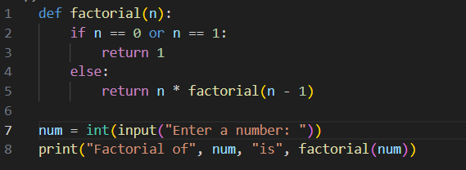

Output :



Python class definition with an initializer and a display method (Task #4)

PROMPT : create a python class definition with an initializer and a display method

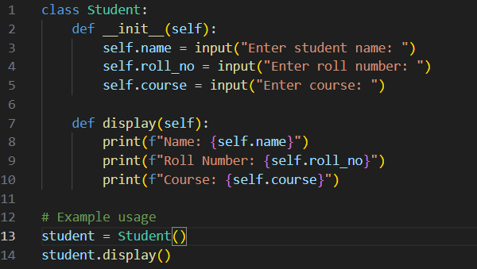

Output :

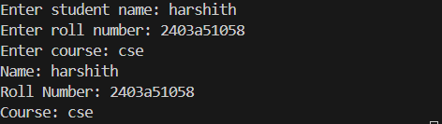

Function that returns word frequency using a dictionary (Task #5)

PROMPT :

Write a python code using a function that returns word frequency using a dictionary

Code :

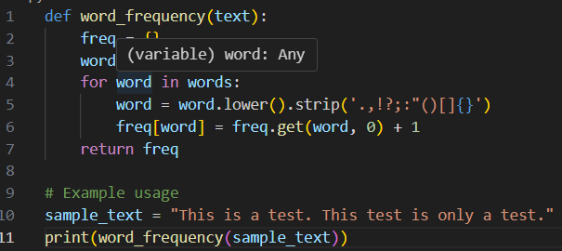

Output :

